CARDIFF COUNCIL – NEW THEATRE CARDIFF - LEASE AVAILABLE
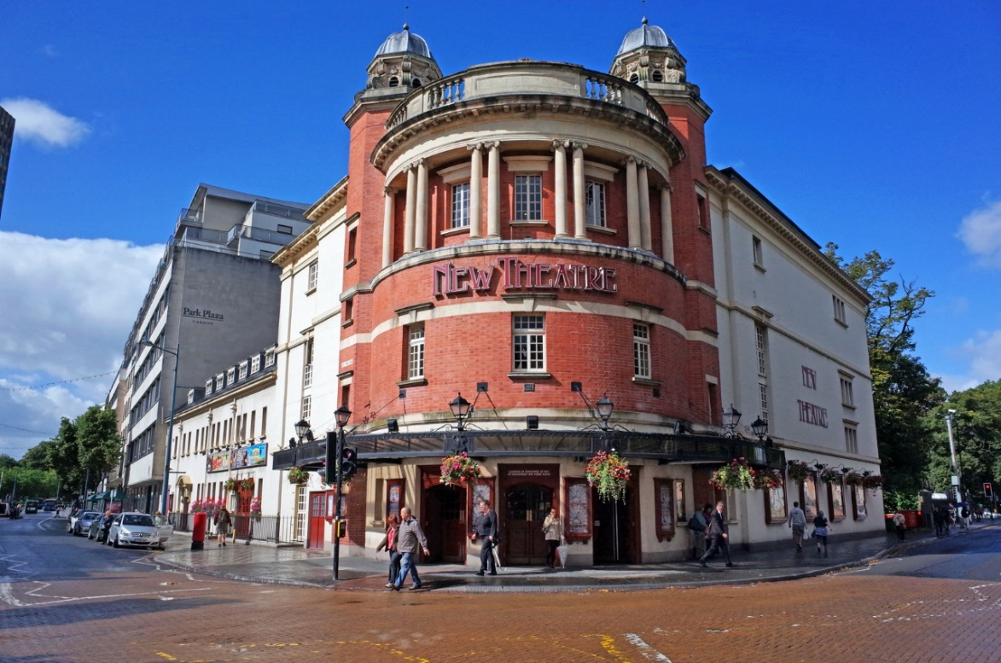
Cardiff Council invites Expressions of Interest from theatre/arts organisations to take a leasehold interest of the prestigious New Theatre, Cardiff.
This 1092 seat capacity Edwardian Theatre opened in 1906, and benefits from:
- City Centre location close to the main shopping area and amongst bars and restaurants
- 3 tiered auditorium
- The stage benefits from a 9.1 m proscenium arch, a 1:24 rake and a grid trim height of 15.7m d/s (c/w 1)
- 3 sections of hydraulically adjustable pit lift
- 12 dressing rooms serving up to 95 performers
- In house lighting and sound provision
- Three foyers each with own bar and one small function room with bar facility
- Office space, with main administration offices on top floor
- Box office located inside the main foyer and separate telesales room available
New Theatre Cardiff has historically provided a mixed year round programme of plays, musicals, children’s shows and dance, as well as Wales’ largest Christmas pantomime. Further details can be found at: www.newtheatrecardiff.co.uk
Cardiff Council is now seeking to negotiate a long term lease to secure investment into the building and to continue its long term future as a theatre.
To submit an initial expression of interest, please download the form [insert link to Expression of Interest form] and return as instructed, together with any other information you feel can support your proposal.
For any queries please email richard.nicholas@cardiff.gov.uk
Closing Date: 5.00pm Friday 1st March 2019

